**Prevent and Counter Terrorism Strategy**

**Introduction**

The Counter Terrorism and Security Act 2015 (updated 21/04/2021) aims to prevent people from being drawn into terrorism and it highlights the need to be vigilant and that we all have a shared responsibility for safeguarding and promoting community cohesion. The Prevent agenda includes international terrorism, Islamist ideology, Right / Neo Nazi / White Supremacist ideology, Incels, Irish Nationalists and Loyalist paramilitary groups and extremist Animal Rights movement. Learning & Skills is an inclusive training and education provider for children, young people, adults and families, including people from ethnically diverse and socially and economically disadvantaged areas and we value and respect responsible freedom of speech.

**Key Definitions**

**Radicalisation:** the process by which a person comes to support terrorism and extremism leading to terrorism.

**Extremism**: is the promotion or advancement of an ideology based on violence, hatred or intolerance, that aims to: negate or destroy the fundamental rights and freedoms of others; or undermine, overturn or replace the UK's system of liberal parliamentary democracy and democratic rights (14 Mar 2024).

The L&S Prevent and Counter Terrorism Strategy objectives:

* to provide appropriate advice and support to prevent people from being drawn into terrorism and ensure they receive the relevant external help
* to respond to ideological challenge, the concept of terrorism, extremism and the threat faced from those who promote these views
* to ensure staff, volunteers and learners are aware of their roles and responsibilities and that L&S has a zero-tolerance approach to bullying, harassment, hate crime and discrimination
* to work in partnership with a range of agencies when there are risks of radicalisation including: police, local communities, health, schools, voluntary sector, charities and faith organisations
* to offer staff, volunteers and learners local and national updates to provide understanding of the issues and have the confidence to deal with them
* to provide an inclusive and flexible curriculum which promotes equality and diversity, challenges extremist accounts and promotes universal rights
* to encourage an inclusive and social cohesive service, with recognition for all faith and cultures and celebrate diversity
* to promote L&S and Fundamental British Values; to enable a forum for open and safe debate so learners have a voice

There is no specific terrorist threat to County Durham and Darlington (Durham Constabulary 2024). However, terrorism remains a real and serious threat to us all. Terrorist and violent extremism activity aims to damage community relations, undermine the values we share and create divisions. The UK Government has a long-term strategy for countering terrorism known as CONTEST. The aim of CONTEST is to reduce the risk to the UK and its citizens and interests overseas from terrorism, so that people can go about their lives freely and with confidence. CONTEST strategy has four strands:

|  |  |  |
| --- | --- | --- |
| **CONTEST’s Risk Reduction Model** | | **Primary Outcome** |
| **Prevent** | Safeguard people from becoming terrorists or supporting terrorism | Reduce intent |
| **Pursue** | Stop terrorist attacks happening in the UK and  oversees | Reduce capability |
| **Protect** | Strengthen our protection against a terrorist attack in the UK or oversees | Reduce vulnerability |
| **Prepare** | Mitigate the impact of a terrorist incidents if it occurs | Reduce impact |

**Marauding terrorist attack** (MTA) is a fast-moving attack where assailants move through a location aiming to find and cause harm to as many people as possible.

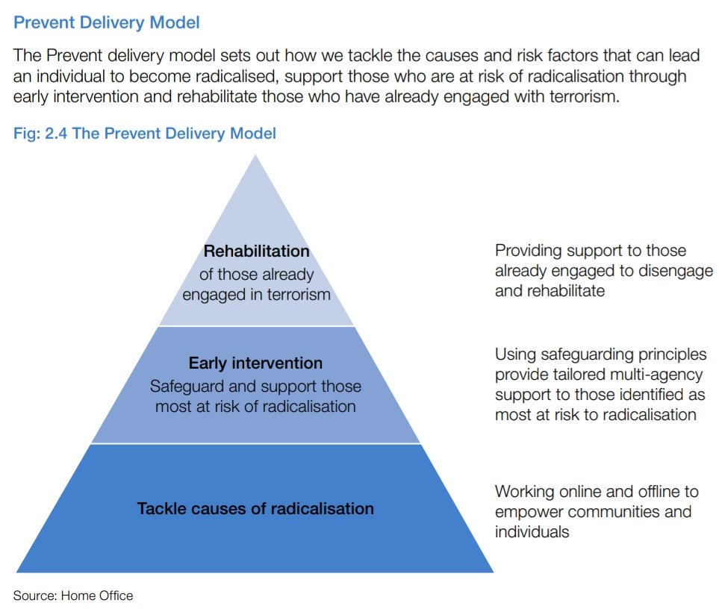

**Channel**

The multi-agency approach to protect people at risk from radicalisation is called Channel. This uses existing collaboration between local authorities, statutory partners (such as the education and health sectors, social services, children and youth services and offender management services), the police and the local community to:

* Identify individuals at risk of radicalisation or involvement in terrorism
* Assess the nature and extent of that risk and
* Develop the most appropriate support plan for the individuals concerned

Channel is about safeguarding children and adults from being drawn into involvement in terrorism. It is about early intervention to address vulnerabilities and divert people from harm.

**Darlington’s Referral Pathway**

**What to do if you have a concern:** If you have a concern that a child / young person or adult

may be at risk of radicalisation or involvement in terrorism, you should speak with the Service:

**Designated Safeguarding Lead / Single Point of Contact (SPOC):**

Alaine McCartney, Learning & Skills Manager

Email [alaine.mccartney@darlington.gov.uk](mailto:alaine.mccartney@darlington.gov.uk)

Telephone: 07816 677851

**Designated Safeguarding Deputy:**

Mally Bleasby, Study Programme Manager

Email [malcolm.bleasby@darlington.gov.uk](mailto:malcolm.bleasby@darlington.gov.uk)

Telephone: 01325 406422 / 07983 996144

**Designated Safeguarding Deputy:**

Graham Curry, Apprenticeship Manager

Email [graham.curry@darlington.gov.uk](mailto:graham.curry@darlington.gov.uk)

Telephone: 01325 405602 / 07949 845325

**Coleridge Centre out of school hours:**

Hummersknott Active - Telephone 07785310214

**Key Contacts and Further Support**

**Children’s Initial Advice Team (CIAT)** open during the following hours: Monday - Thursday: 8:30am - 5pm & Friday: 8:30am - 4:30pm

Telephone: Professionals 01325 406252 / Public 01325 406222

E-mail: [childrensfrontdoor@darlington.gov.uk](mailto:childrensfrontdoor@darlington.gov.uk)

If you need to get in touch out of office hours and bank holidays, contact the Emergency Duty Team on **01642 524552**

**First Point of Contact Team (Adults)** open during the following hours: Monday - Friday: 9:00am - 5pm

Telephone: 01325 406111 / Text 07538 601527

E-mail: [ssact@darlington.gov.uk](mailto:ssact@darlington.gov.uk)

Concern form: <https://www.darlington-safeguarding-partnership.co.uk/about-us/worried-about-an-adult/>

If you need to get in touch out of office hours and bank holidays, contact the Emergency Duty Team on **01642 524552**

**Education:**

Angela Turnbull - Education Safeguarding Officer

Email [angela.turnbull@darlington.gov.uk](mailto:angela.turnbull@darlington.gov.uk)

Telephone: 01325 405848 / 07940 000845

**Darlington Borough Council Prevent Lead**

Chris Knox - Head of Community Safety

Email [chris.knox@darlington.gov.uk](mailto:chris.knox@darlington.gov.uk)

Telephone: 01325 406754

**Channel Panel:**

Jo Benson - Youth Offending Manager

Email [joanne.benson@darlington.gov.uk](mailto:joanne.benson@darlington.gov.uk)

Telephone: 01325 406791

**Call 999 if there is an immediate threat to life.**

**Police Prevent Team** (office hours) 0191 375 2234 / [prevent@durham.pnn.police.uk](mailto:prevent@durham.pnn.police.uk)

If you have information about possible terrorist activity call Durham Constabulary on 101 for non-urgent and 999 for emergency calls.

**To report illegal information, pictures or videos found on the internet**

[www.gov.uk/report-terrorism](http://www.gov.uk/report-terrorism)

**Confidential National Anti-terrorist hotline:** 0800 789 321

**Due Diligence and Counter Extremism Group** (DDCEG) Helpline - (020 7340 7264) For education staff and governors to raise concerns relating to extremism directly and in confidence

<http://educateagainsthate.com/>



<https://actearly.uk/>

[https://assets.publishing.service.gov.uk/government/uploads/system/uploads/attachment_data](https://assets.publishing.service.gov.uk/government/uploads/system/uploads/attachment_data/file/716907/140618_CCS207_CCS0218929798-1_CONTEST_3.0_WEB.pdf)

<https://www.cpni.gov.uk/>

https://www.durham.police.uk/Information-and-advice/counter-terrorism/Pages/default.aspx

<https://www.et-foundation.co.uk/supporting/professional-development/inclusion/prevent//>

<https://www.gov.uk/government/publications/channel-guidance>

<http://www.gov.uk/government/publications/prevent-duty-guidance>

<https://www.gov.uk/government/publications/prevent-duty-guidance>

<https://www.gov.uk/government/publications/protecting-children-from-radicalisation-the-prevent-duty>

https://www.ltai.info/what-is-prevent

**Prevent Duty Risk**

|  |  |  |  |
| --- | --- | --- | --- |
| **No** | **Prevent Vulnerability/Risk Area** | **Action taken/already in place to mitigate/address risk** | **Owner** |
| 1 | **Leadership:**   1. Local Authority Management 2. SLT 3. Staff 4. Safeguarding team | a) All staff including Leaders complete Prevent via Academy 10 and Prevent Duty is discussed by Council. Directors annual report in July.  Assistant Director briefed on Prevent threat/risk.  b) SLT members are WRAP trained, contribute to developing the Prevent Strategy and receive monthly updates.  c) All staff including volunteers have completed Prevent online – DSCB & Home Office.  All Prevent training recorded on the Single Central Record and refresher every 3 years.  d) DSL & DSDs have completed Prevent & Channel online. WRAP, Train the Trainer and L3 DSL Safeguarding. Safeguarding / Prevent Working Group bi-monthly. Action Plan reviewed every month. | **PR**  **AM**  **AM**  **AM, GC & MB** |
| 2 | **Partnership:**   1. Active engagement from the institution's SLT, managers and leaders. 2. The institution has an identified single point of contact (SPOC) Prevent. 3. The institution engages with Local Police, Prevent Leads and local Prevent Boards. | a) DBC internal communications, information sharing from the Education Safeguarding Officer & Community Resilience. Education Quarterly Report includes information of any Prevent activity or threat/risk to L&S /DBC.  b) DSL is the Service SPOC, during absence DSD in attendance at all times. Induction PowerPoint, Learner Handbook, Safeguarding poster.  DBC SPOC – Angela Turnbull, Education / James Gallagher, Community Resilience  c) Chris SybengaG7-Prevent Regional HE/FE Co-ordinator DfE /  James Gallagher, Community Resilience / Angela Turnbull, Education /  Silver Group / Professional Exchange Northeast. | **AM**  **AM**  **AM** |
| 3 | **Staff Training:**   1. Evident FBV in management, teaching and behaviours. 2. Demonstrate the factors that make people vulnerable to being drawn into terrorism and challenge extremist ideas. 3. Sufficient training to be able to recognise vulnerability and aware of action to take. 4. Front line staff have the tools and knowledge to impart knowledge of Prevent in a contextualised way. | a) Corporate induction, Deep Dive themes, circulated good practice, Padlet, Best Practice Toolkit.  b) All staff encouraged to attend Staff Briefings with a focus on Fundamental BV and Prevent Duty.  Bi-weekly E&D quiz with detailed answers produced by teaching staff  Monthly NE Newsletter from the DfE.  c) Annual Prevent health check for all staff to identify training need. 100% of staff and volunteers have completed Prevent online – DSCB & Home Office. 100% of staff and volunteers have completed WRAP training.  d) Identify and stop unauthorised visitors training.  Visitor Information Card.  Bi-weekly E&D quiz.  Monthly NE Newsletter from the DfE. | **SLT**  **All Staff**  **AM**  **AM** |
| 4 | **Welfare and pastoral support:**   1. Adequate arrangements and resources for pastoral care. 2. Adequate monitoring arrangements is effective supporting welfare & equality. 3. Support reflects the learner’s demographic and need. | a) Referral procedure for the Service Mentor and Career Guidance Adviser and Intensive Support. Cause for Concern process. Alliance Counselling.  b) Coordinated approach is taken to support learners who may be vulnerable. Individual intervention observation, ILPs.  Curriculum managers discuss in monthly team meetings  c) ILPs inclusive and responsive to need. S:\L&S\IntensiveSupport\ISData.  ILR postcode. EDIM’s. | **EK & SLT**  **EK, SLT**  **SLT** |
| 5 | **Speakers and Events:**   1. An effective policy for managing speaker requests. 2. Communications to staff/learners. 3. Framework for managing events. 4. Offsite events are supported, endorsed, funded & organised to the policy. | a) S:\Learning and Skills\QA Policies\External Speakers Policy  b) WISE  Team meetings  c) S:\L&S\Safeguarding\Prevent\Guest Speaker Risk Assessment and S:\L&S\Risk Assessments  d) Enrolment form signed declaration,  S:\L&S\ QA Policies\Code of Conduct.  S:\L&S\ QA Policies\Health & Safety. | **AM**  **IS & SLT**  **AM**  **QIG** |
| 6 | **Safety Online:**   1. Policy relating to the use of IT with specific reference and inclusion of the Prevent Duty 2. Filtering/firewall systems to prevent access to extremist websites and material. 3. Alerts to serious and/or repeated breaches or attempted breaches. | a) Acceptable Use Policy  S:\Learning & Skills\QA Policies\AUP  b) Xentrall – McAfee Web Gateway. Category based filtering system  Internal checks conducted every 3 months S:\L&S\Safeguarding\Prevent\Softwarecheck 2019.  Does not include learners using their own devices via Wi-Fi.  c) Random checks by Xentrall.  Briefing via Communications.  Email notifications to staff. | **IS**  **Xentrall**  **GC, MB, CB**  **Xentrall** |
| 7 | **Learner Knowledge:**   1. Learners have sufficient knowledge of FBV, Prevent and Radicalisation. 2. Learners recognise when self/peer might be radicalised. 3. Learners know how to report a Prevent issue. | a) Induction video delivered to all learners. HJJ delivers bespoke information sessions.  Learners are encouraged to complete Prevent online. Bi-weekly quiz with learners on relevant themes, walkthroughs, Deep Dives, website, posters.  b) Induction video, learner handbook, Deep Dives, walkthroughs, guest speakers, visual displays.  c) Induction video, learner handbook, displayed posters with DSL / DSD photographs and contact details, bi-weekly quiz. | **AM, HJJ**    **All Staff**  **All Staff** |
| 8 | **Prayer and Faith Facilities:** | No, but could provide a quiet place if requested. | **Managers** |
| 9 | **Security:**   1. Effective arrangements to manage access to the buildings. 2. Policy enforced regarding the wearing of ID on site. 3. Policy covering the distribution (& electronic) of leaflets and publicising material. | a) All staff, volunteers, learners and visitors sign-in at all L&S venues. Visitor information card distributed at sign-in. Hummersknott Active. Buzz-in system at 2 venues.  b) All staff must wear an ID badge.  Learner and visitor badges (BV lanyards with alternating themes) Information is included in the Learner Induction PP.  c) S:\L&S\QAStrategies\Marketing Publicity and Recruitment Strategy. | **AM**  **All Staff**  **IS** |
| 10 | **Safeguarding:**   1. Risk of radicalisation and extremism is included within Safeguarding policies. 2. DSL/DSDs receive effective training relating to radicalisation and extremism. 3. L&S utilise Channel as a support mechanism in cases of radicalisation and extremism. 4. L&S have a policy regarding referral to Channel. | a) S:\L&S\QA Procedure\Safeguarding Procedure  S:\L&S\QA Policies\Safeguarding Policy  Both documents renewed bi-annually.  b) DSL and DSDs receive up to date training from the local authority Education Safeguarding Officer, police, schools/college and home office.  Training circulated by the regional HE/FE Prevent Co-ordinator.  c) Referrals to Channel is via DSL and DSDs who have completed the home office Channel online.  Partnership working with the local authority Prevent team and DSP.  d) Prevent Practice Guidance and Channel Process  <https://www.darlington-safeguarding-partnership.co.uk/media/1967/prevent-channel-process-july-19-dsp11.pdf> | **AM**  **AM, MB, GC**  **AM**  **AM** |
| 11 | **Communications:**   1. The Prevent lead and their role is widely known across L&S. 2. Staff and learners made aware of the Prevent Duty and local activity. 3. The value of learners/staff understanding of Prevent. 4. Information sharing protocols in place to Prevent partners. | a) Displayed posters with photographs, induction video, learner handbook, walkthroughs, WISE.  b) Local picture and level of risk circulated via monthly NE Newsletter, bi-monthly quiz, staff training.  Distribution of the monthly DfE newsletter and DBC circular.  c) Annual Prevent health check, monitoring visits, Deep Dives, QIP.  Curriculum plans and evaluation.  d) Padlet, Community Resilience Officer, Education Safeguarding Officer, Tees Valley Local Authorities, Regional HE/FE Prevent Co-ordinator. | **AM**  **All Staff**  **SLT, QIG**  **AM** |
| 12 | **Incident Management:**   1. Critical incident management 2. DBC trained and informed persons identified to lead. 3. Communications respond to incidents. 4. L&S have effective plans for staff/learners and/or public safety. 5. DBC arrangements to appraise tensions and provide advice. | a) Business Continuity Plan includes dealing terrorist related issues and public disorder.  b) Peter Bodo & Kevin Archbold  Civil Contingencies, Joint response team to a terror related incident.  c) Talking to the media and press release co-ordinated by DBC Communication Team  <http://intranetdarlington.gov.uk/communications>  d) Health & Safety, Employer Handbook, Learner Handbook, Risk Assessments, Cause for Concern, Code of Conduct, Comments, Compliments & Complaints. (npsa-ingress-egress-guidance)  e) Monthly update and central communications.  Immediate email alerts. | **PR**  **AM**  **SLT, DBC**  **SLT, DBC**  **SLT, DBC** |
| 13 | **Staff and Volunteers:**   1. Volunteers receive awareness training. | a) All volunteers complete Prevent online, Safeguarding Children and Adults.  WISE, monthly newsletters, DBC circular. | **AM** |
| 14 | **Freedom of Expression:**   1. DBC has a Freedom of Speech/Expression policy. 2. The policy recognises risks with radicalisation/extremism. 3. The need to protect vulnerable individuals is covered within this policy. | a) Code of Conduct Policy 2018, Whistleblowing Policy 2018, Social Media Policy 2015, Learner Information Pack, S:\Learning and Skills\QA Policies\External Speakers Policy  b) Learner Information Pack  S:\Learning and Skills\QA Policies\External Speakers Policy  c) Learner Information Pack  S:\L&S\QAProcedure\Safeguarding Procedure  S:\L&S\QAPoloicies\Safeguarding Policies  S:\Learning and Skills\QA Policies\External Speakers Policy  <http://intranet.darlington.gov.uk/services-search/hr/academy-10/academy-10-for-staff/> | **AM**  **AM**  **AM** |

|  |  |  |  |
| --- | --- | --- | --- |
| Version | Issued | Next Review | Contact |
| 12 | January 2025 | January 2026 | Alaine McCartney |